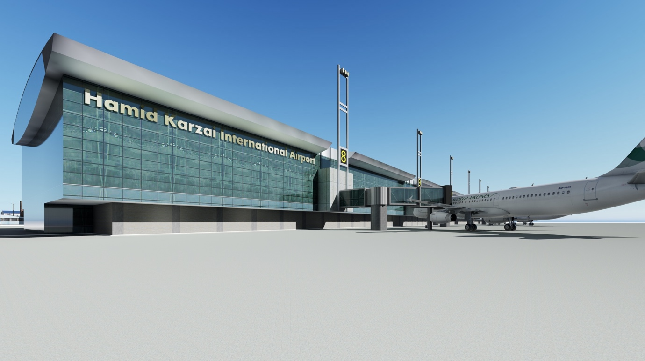

CALL FOR EXPRESSION OF INTEREST
APRIL 2020
DEVELOPMENT OF AN AIRPORT HOTEL
AT HAMID KARZAI INTERNATIONAL AIRPORT
UNDER PUBLIC PRIVATE PARTNERSHIP (PPP) FRAMEWORK

AFGHANISTAN CIVIL AVIATION AUTHORITY
Kabul International Airport, Ansari Wat, Kabul, Afghanistan

DISCLAIMER

This invitation for Expression of Interest (EOI) is not an offer by the Afghanistan Civil Aviation Authority (ACAA), but an invitation to receive responses from entities that are interested in the development of the airport hotel at HKIA under PPP framework (the “Project”).

No contractual obligation whatsoever shall arise from the EOI process unless and until a formal contract is signed and executed between ACAA and the entities concerned.

ACAA reserves the right not to proceed with the Project.

CONTENTS

1. INTRODUCTION 4
2. BACKGROUND 4
3. KEY FEATURES OF THE PROJECT 5
4. PROJECT COMPONENTS & BENEFITS 5
5. SATELLITE IMAGE OF THE PROJECT SITE 6
6. PROJECT SITE IMAGES 6
NOTICE INVITING GLOBAL EXPRESSION OF INTEREST (EOI) 9
MODE & MANNER OF SUBMISSION 10
PRE-EOI QUERIES 11
SCHEDULE OF EVENTS 11
FORMATS FOR EOI SUBMISSION 11

INTRODUCTION

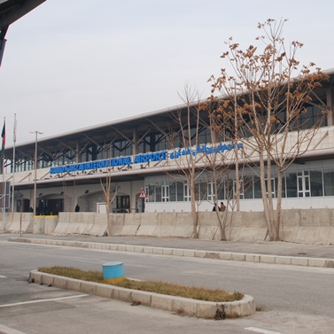
The Islamic Republic of Afghanistan, is a landlocked country located in Central Asia and borders a multitude of countries from Turkmenistan, Uzbekistan, and Tajikistan in the north; Iran on the west; Pakistan on its east and south to China on the north east. With two-thirds of the country’s geography being composed of Central highlands and hilly terrain, air transport is the most vital, time-saving mode of transportation. The air transport in the country is provided by a number of international, domestic, regional and military airports.

The Hamid International Karzai Airport (HKIA) is a State owned airport and is operated by the Afghanistan Civil Aviation Authority (ACAA) (hereinafter referred to as the “Authority”), an entity constituted by the Government of Afghanistan (GoA). HKIA is the busiest airport in the country and carries more than 90% of the air- traffic to and from the country.

With the increase in the number of international visitors and investments in recent years, development of an international airport hotel within HKIA in Kabul appears to a much required, relevant and useful infrastructure that would cater to the international as well as domestic business enterprises and tourists.

BACKGROUND

The Authority has already carried out a feasibility study and developed a business case for development of airport hotel within HKIA. The Authority proposes development of the airport hotel through Design-Build-Finance-Operate-Transfer (DBFOT) mode under Public Private Partnership framework (hereinafter referred to as the “Project”).

The Authority intends to adopt a transparent, competitive bidding process to select private sector Developer for implementation of the Project.

As a first step in this direction, it has invited global EoI for Project development, from interested private sector parties, so as to assess the interest of the market in the bidding for Project development and also understand the concerns of private sector, if any with
respect to the Project.

KEY FEATURES OF THE PROJECT

The key features of the Project are as follows:
- Development of 190 room four-star category airport hotel
- Estimated Project cost of development is about USD 63 million
- Project site admeasuring an area of 40,000 square meters (“Project Site”) within the secure perimeter of HKIA has been earmarked by the Authority for the Project implementation
- The Project site is free of encumbrance and encroachments
- The Authority holds the right and title over the Project site.
- The Project is proposed for development over a concession period of about thirty years which also includes two years of construction period.
- The private sector Developer selected by way of a competitive bidding process would design, finance and construct the airport hotel; operate and manage the airport hotel over the concession period; and at the end of the concession period, shall transfer the airport hotel back to the Authority.
- In consideration to the grant of concession/ rights by the Authority to the private sector Developer, the private sector Developer may be required to make periodic payments (concession payments) to the Authority over the concession period.

PROJECT COMPONENTS & BENEFITS

Airport Hotel - the first luxury hotel to be developed under PPP framework in Afghanistan

SATELLITE IMAGE OF THE PROJECT SITE

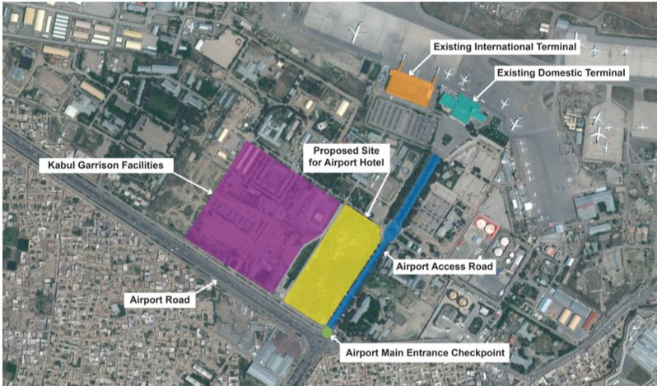

PROJECT SITE IMAGES

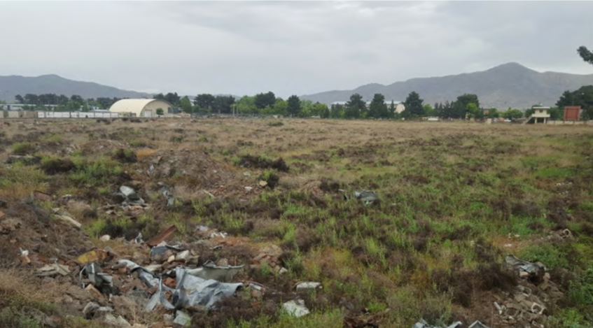

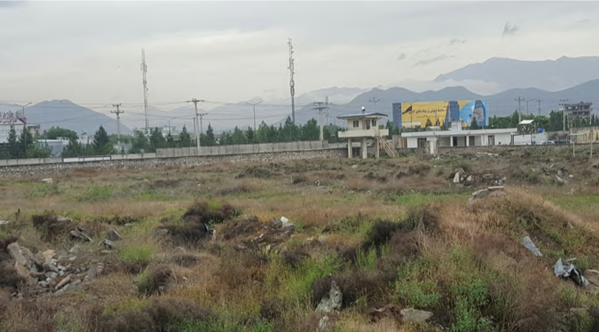

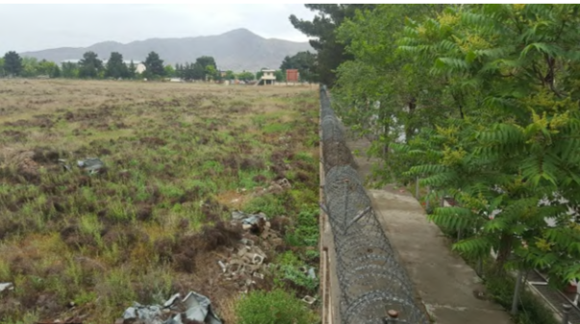

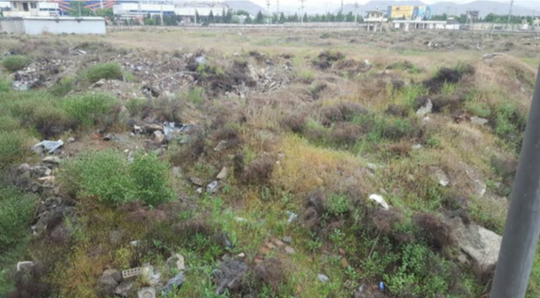

NOTICE INVITING GLOBAL EXPRESSION OF INTEREST (EOI)

DEVELOPMENT OF AIRPORT HOTEL AT HAMID KARZAI INTERNATIONAL AIRPORT
UNDER PUBLIC PRIVATE PARTNERSHIP (PPP) FRAMEWORK

Afghanistan Civil Aviation Authority (ACAA) (hereinafter referred to as the “Authority”) is responsible for the operation and management of the Hamid Karzai International Airport (HKIA) at Kabul. It is one the major international airports of Afghanistan which handles an average of 2 million passengers arrivals per annum, which has been increasing steadily over the years. Given the widespread development of infrastructure and economy in Afghanistan, the Authority is actively pursuing development of ancillary infrastructure facilities at HKIA to provide world class infrastructure service delivery and experience to all its stakeholders, especially, the passengers.

Development of 190 room four-under star category airport hotel at HKIA through Design-Build-Finance-Operate-Transfer (DBFOT) mode under PPP framework (hereinafter referred to as the “Project”) is one of the several projects that the Authority is desirous to implement. The Authority has earmarked an area of 40,000 square meters (“Project Site”) within its security perimeter for development of the Project. The Project Site is in good condition and is free of any encumbrance. The estimated Project cost of development of the airport hotel is estimated at USD 63 million. The scope of the private sector would include design, finance and construct the airport hotel, operate and manage the hotel for a period of about thirty (30) years; and at the end of which, transfer the airport hotel back to the Authority.

In light of the above, the Authority hereby invites this ‘Global Expression of Interest’ from eligible private sector investors/ developers/ operators, in individual capacity or as part of a Consortium, having experience in financing, construction, operation and management of projects of similar nature.

Interested parties should submit/send their EOI for the proposed Project, as per the formats set out in the EOI document in sealed cover to the Mr. Amanzeb Ansari, Chief of Staff, Afghanistan Civil Aviation Authority, Kabul international Airport, Ansari Wat, Kabul, Afghanistan.

Note: In case of clarification, please feel free to contact us at the details mentioned below:

Mr. Amanzeb Ansari
Senior Planning and Policy Advisor
Afghanistan Civil Aviation Authority
Kabul international Airport
Ansari Wat, Kabul, Afghanistan
Email: ansari@acaa.gov.af
amanzeb.ansari@gmail.com
Phone# 0093 77 1001001

MODE & MANNER OF SUBMISSION

The Authority invites ‘Global Expression of Interest’ (EOI) from eligible private sector investors/ developers and operators who have experience in financing, construction, operation and management of projects of similar nature, either in individual capacity or in the capacity of a Consortium.

The EOI is invited to give an opportunity to interested parties to share their view / requirements on the Project and issues/ concerns, if any on the development model selected for Project implementation. The ultimate objective of the EoI is to structure the Project in such a way that it attracts maximum private sector participation for development.

The EOI may either be submitted in response to the suggested pattern of development detailed herein above or the potential Applicants are welcome to propose alternate development models, which shall be examined by the Authority, prior to commencement of the bidding process for selection of the private Developer for Project.

Interested Applicants should submit/send their EOI with all required information(s) requested in the formats shared under this EOI, on or before __.__.2020 upto 1600 Hrs in the two formats mentioned below:

- Soft copy of EOI and scanned copies of all accompanying documents sent via email to amanzeb.ansari@gmail.com with the title:
“Expression of Interest (EOI) for the development of Airport Hotel at HKIA under PPP framework”

- Printed copy of EOI together with all accompanying documents in a plain sealed envelope clearly marked as:

“Expression of Interest (EOI) for the development of Airport Hotel at HKIA under PPP framework”

EOI shall be submitted in English language only and may include supporting documents about the Applicant and its relevant experience.

The EoI shall be hand delivered (including courier services) to the following address:

Mr. Amanzeb Ansari
Senior Planning and Policy Advisor
Afghanistan Civil Aviation Authority
Kabul international Airport
Ansari Wat, Kabul, Afghanista

PRE-EOI QUERIES

The interested Applicants may seek clarifications on any of the information provided in this request for EOI in writing email to ACAA at the address mentioned below. All queries should be sent via email to amanzeb.ansari@gmail.com before ______ (Kabul time) on ________

SCHEDULE OF EVENTS

With respect to the EOI process, the Authority shall endeavor to abide by the schedule of events set out below;

Events | Date & Time
Last date for receipt of queries | __.__.2020 at __.__ hrs.
Last date & time for EOI Submission: | __.__.2020 at 16:00 hrs.

FORMATS FOR EOI SUBMISSION

FORMAT – 1
COVER LETTER FOR EXPRESSION OF INTEREST
(To be furnished on the letter head of the Applicant)

To:
Mr. Amanzeb Ansari
Senior Planning and Policy Advisor
Afghanistan Civil Aviation Authority
Kabul international Airport
Ansari Wat, Kabul, Afghanistan
Email: ansari@acaa.gov.af
amanzeb.ansari@gmail.com
Phone# 0093 77 1001001

Sub: Submission of Expression of Interest for Development of Airport Hotel at Hamid Karzai International Airport under Public Private Partnership Framework

Dear Sir/ Madam:

In response to the Invitation for Expressions of Interest (EOI) dated___________ for the above purpose, we would like to express interest to carry out the above proposed task.

As instructed, we attach 2 sets of the following documents in separately sealed envelopes and one soft copy:
1. Organizational Details (Format-2)
2. Experience in related fields (Format-3)
3. Financial strength of the organization (Format-4)
4. Additional information (Format-5)
5. Declaration (Format-6)

Sincerely Yours,

Signature of the Authorised Signatory of the Applicant
Full name and Designation of the Authorised Signatory of the Applicant

Stamp & Date

Enclosure: As stated above

FORMAT 2
APPLICANT DETAILS

No. | Particulars | Details
1 | Name of the Applicant
2 | Main Areas of Business
3 | Nature of Applicant  (Specify whether - Sole Proprietorship/ Partnership/ Company/ Limited Liability Partnership)
4 | Whether the Applicant has been blacklisted by any Government Instrumentality/ Other entity? If yes, provide details thereof.
5 | Contact details of Registered Office (address with telephone no. & fax no. and email address)
6 | Contact details of Other Offices (address with telephone no. & fax no. and email address) of the Applicant
7 | Contact Details of Concerned/ Designated Officer (address with telephone no. & fax no. and email address) of Applicant

Enclosed:

- Copy of Certificate of Incorporation/ Certificate of Registration of Partnerships/ valid proof of the nature of the Applicant
- Undertaking with respect to point no.4 above

Signature of the Authorised Signatory of the Applicant
Full name and Designation of the Authorised Signatory of the Applicant

Stamp & Date

FORMAT 3
RELEVANT EXPERIENCE

No. | Experience | Name of the project | Total Project Cost (in USD million) | Date of commencement of commercial operations | Number of rooms | Other Facilities in the Hotel | Duration of O&M Experience | Whether developed under PPP framework? | If PPP, then name, address, phone number, email address of the Public Authority
1 | Construction, operation and management of a four star or above category of an airport hotel of at least 100 rooms anywhere in the world
2 | Operation and Management of a four star or above category of an airport hotel of at least 150 rooms anywhere in the world
3 | Construction, operation and management of a four star or above category hotel of at least 100 rooms anywhere in the world
4 | Operation and Management of a four star or above category hotel of at least 150 rooms anywhere in the world
5 | Construction, operation and management of a four star or above category hotel of at least 75 rooms in Afghanistan
6 | Operation and Management of a four star or above category hotel of at least 100 rooms in Afghanistan
7 | Any other relevant experience

Note: Add additional rows to furnish relevant experience of multiple projects

Signature of the Authorised Signatory of the Applicant
Full name and Designation of the Authorised Signatory of the Applicant

Stamp & Date

FORMAT 4
FINANCIAL EXPERIENCE

Financial Year | Net Worth (in USD million) | Annual Cash flows (USD million)
2015-16
2016-17
2017-18
2018-19
2019-20

Enclosed:

- Certificate from the Statutory Auditor with respect to the validity of the above
- Audited Annual Financial Statements (including Balance Sheet, Cash flow Statement and Profit and Loss Statement) for the last three financial years.

Signature of the Authorised Signatory of the Applicant
Full name and Designation of the Authorised Signatory of the Applicant

Stamp & Date

FORMAT 5
ADDITIONAL INFORMATION

No. | Enclosures that form part of previous sections | Name and Description | Number of Pages
1
2
3
No. | Additional Information to support relevant experience and financial experience | Name and Description | Number of Pages
1
2
3
4

Note: Add additional rows, if necessary

Signature of the Authorised Signatory of the Applicant
Full name and Designation of the Authorised Signatory of the Applicant

Stamp & Date

FORMAT 6
DECLARATION
(To be furnished on the letter head of the Applicant)

To:
Mr. Amanzeb Ansari
Senior Planning and Policy Advisor
Afghanistan Civil Aviation Authority
Kabul international Airport
Ansari Wat, Kabul, Afghanistan
Email: ansari@acaa.gov.af
amanzeb.ansari@gmail.com
Phone# 0093 77 1001001

Sub: Submission of Expression of Interest for Development of Airport Hotel at Hamid Karzai International Airport under Public Private Partnership Framework

Dear Sir/ Madam:

We hereby confirm that we are interested to undertake the Project, ‘Development of Airport Hotel at Hamid Karzai International Airport under PPP framework’.

All the information provided herewith is genuine and accurate.

Sincerely Yours,

Signature of the Authorised Signatory of the Applicant
Full name and Designation of the Authorised Signatory of the Applicant

Stamp & Date

As of [insert month and year, of estimation]

