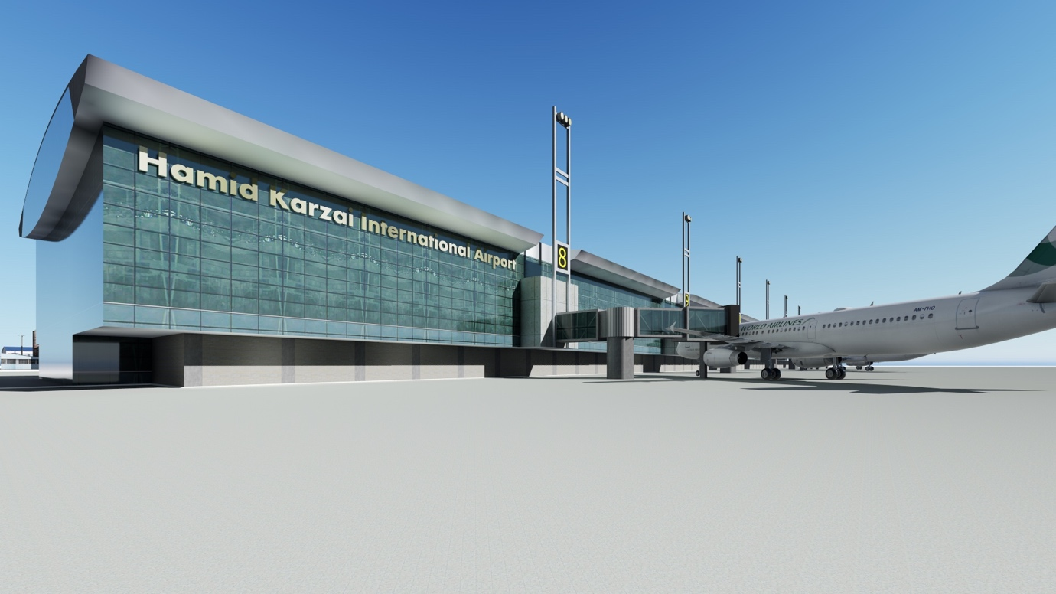
DEVELOPMENT OF AN AIRPORT
INTERNATIONAL PASSENGER TERMINAL
AT HAMID KARZAI INTERNATIONAL AIRPORT
UNDER PUBLIC PRIVATE PARTNERSHIP (PPP) FRAMEWORK

AFGHANISTAN CIVIL AVIATION AUTHORITY
Kabul International Airport, Ansari Wat, Kabul, Afghanistan

CALL FOR EXPRESSION OF INTEREST
APRIL 2020

DISCLAIMER

This invitation for Expression of Interest (EOI) is not an offer by the Afghanistan Civil Aviation Authority (ACAA), but an invitation to receive responses from entities that are interested in the development of the international passenger terminal at HKIA under PPP framework (the “Project”).

No contractual obligation whatsoever shall arise from the EOI process unless and until a formal contract is signed and executed between ACAA and the entities concerned.

ACAA reserves the right not to proceed with the Project.

CONTENTS

1. INTRODUCTION 4
2. BACKGROUND 4
3. CURRENT STATUS 4
4. KEY FEATURES OF THE PROJECT 5
5. PROJECT COMPONENTS 5
6. SATELLITE IMAGE OF THE PROJECT SITE 6
7. PROJECT SITE IMAGES 6
NOTICE INVITING GLOBAL EXPRESSION OF INTEREST (EOI) 8
MODE & MANNER OF SUBMISSION 9
PRE-EOI QUERIES 9
SCHEDULE OF EVENTS 10
FORMATS FOR EOI SUBMISSION 10

INTRODUCTION

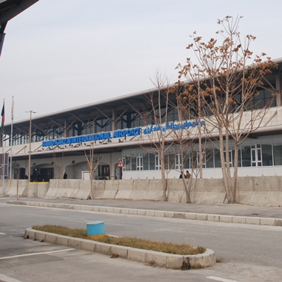
The Islamic Republic of Afghanistan, is a landlocked country located in Central Asia and borders a multitude of countries from Turkmenistan, Uzbekistan, and Tajikistan in the north; Iran on the west; Pakistan on its east and south to China on the north east. With two-thirds of the country’s geography being composed of Central highlands and hilly terrain, air transport is the most vital, time-saving mode of transportation. The air transport in the country is provided by a number of international, domestic, regional and military airports.

The Hamid International Karzai Airport (HKIA) is a State owned airport and is operated by the Afghanistan Civil Aviation Authority (ACAA) (hereinafter referred to as the “Authority”), an entity constituted by the Government of Afghanistan (GoA). HKIA is the busiest airport in the country and carries more than 90% of the air- traffic to and from the country.

The market demand for air passenger services within Afghanistan is strong with growth projected to reach 2.9 million passengers per annum by 2025. With the increase in the number of international visitors and investments in recent years, development of an international passenger terminal (IPT) within HKIA in Kabul appears to a much required, relevant and useful infrastructure that would cater to the international as well as domestic travelers to and from HKIA, Kabul.

BACKGROUND

The Authority has already carried out a feasibility study and developed a business case for development of an IPT within HKIA. The Authority proposes development of an international passenger terminal (IPT) through Design-Build-Finance-Operate-Transfer (DBFOT) mode under Public Private Partnership framework (hereinafter referred to as the “Project”).

The Authority intends to adopt a transparent, competitive bidding process to select private sector Developer for implementation of the Project.

As a first step in this direction, it has invited global EoI for Project development, from interested private sector parties, so as to assess the interest of the market in the bidding for Project development and also understand the concerns of private sector, if any with
respect to the Project.

CURRENT STATUS

A terminal for international flights was constructed in 2008 at Hamid Karzai International Airport with a grant aid from Japan International Cooperation Agency (JICA). Financial assistance of USD 31 million was provided for expansion and renovation of aircraft parking aprons and an addition USD 40.6 million was provided for improving security at the HKIA. The airport terminal has two adjacent buildings – one for international flights and the other one for domestic flights. A cargo terminal is located on the south of the domestic airport.

KEY FEATURES OF THE PROJECT

The key features of the Project are as follows:
- Development of an international passenger terminal at HKIA
- Estimated Project cost of development is about USD 268 million
- Project site measuring an area of 55,700 square meters (“Project Site”) within the secure perimeter of HKIA has been earmarked by the Authority for the Project implementation
- The international passenger terminal is proposed to be expanded to approximately 39,000 square meters to accommodate 3.5 million passengers per annum in Phase I (2021-2036) and to approximately 16,700 squares meters to accommodate up to 6 million passengers by 2051. As per ACAA, the passenger terminal should be built eventually to handle 10 million passengers per annum in future.
- ACAA is in the process of land acquisition and making it ready for development
- The Authority holds the right and title over the Project site
- The Project is proposed for development over a concession period of about thirty years which also includes two years of construction period in Phase I and a one and half years of construction period for Phase II, which will begin after 15 years of concession period.
- The private sector Developer selected by way of a competitive bidding process would design, finance and construct the IPT; operate and manage IPT over the concession period; and at the end of the concession period, shall transfer the IPT back to the Authority.
- In consideration to the grant of concession/ rights by the Authority to the private sector Developer, the private sector Developer may be required to make periodic payments (concession payments) to the Authority over the concession period

PROJECT COMPONENTS

The following are the main components of the Project development –

SATELLITE IMAGE OF THE PROJECT SITE

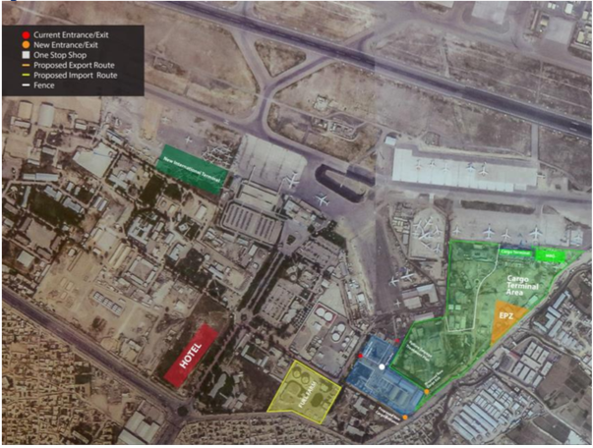

PROJECT SITE IMAGES
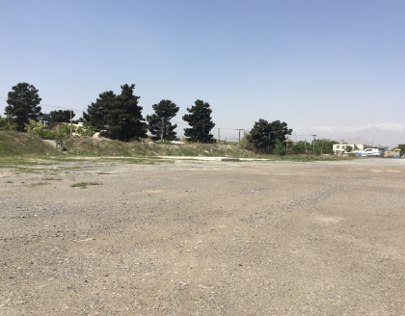

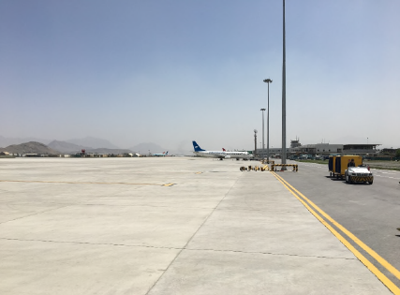

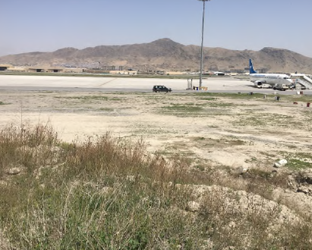

NOTICE INVITING GLOBAL EXPRESSION OF INTEREST (EOI)

DEVELOPMENT OF AN INTERNATIONAL PASSENGER TERMINAL AT HAMID KARZAI INTERNATIONAL AIRPORT UNDER PUBLIC PRIVATE PARTNERSHIP (PPP) FRAMEWORK

Afghanistan Civil Aviation Authority (ACAA) (hereinafter referred to as the “Authority”) is responsible for the operation and management of the Hamid Karzai International Airport (HKIA) at Kabul. It is one the major international airports of Afghanistan which handles an average of 2 million passengers per annum, which has been increasing steadily over the years. Given the widespread development of infrastructure and economy in Afghanistan, the Authority is actively pursuing development of ancillary infrastructure facilities at HKIA to provide world class infrastructure service delivery and experience to all its stakeholders, especially, the passengers.

Development of an international passenger terminal (IPT) at HKIA through Design-Build-Finance-Operate-Transfer (DBFOT) mode under PPP framework (hereinafter referred to as the “Project”) is one of the several projects that the Authority is desirous to implement. The Authority has earmarked an area of 55,700 square metres (“Project Site”) within its security perimeter for development of the Project. The Project Site is in good condition and ACAA is in the process of making the land ready for development. The estimated Project cost of development of IPT is estimated at USD 268 million. The scope of the private sector would include design, finance and construct IPT, operate and manage the same for a period of about thirty (30) years; and at the end of which, transfer IPT back to the Authority.

In light of the above, the Authority hereby invites this ‘Global Expression of Interest’ from eligible private sector investors/ developers/ operators, in individual capacity or as part of a Consortium, having experience in financing, construction, operation and management of projects of similar nature.

Interested parties should submit/send their EOI for the proposed Project, as per the formats set out in the EOI document in sealed cover to the Mr. Amanzeb Ansari, Chief of Staff, Afghanistan Civil Aviation Authority, Kabul international Airport, Ansari Wat, Kabul, Afghanistan.

Note: In case of clarification, please feel free to contact us at the details mentioned below:

Mr. Amanzeb Ansari
Senior Planning and Policy Advisor
Afghanistan Civil Aviation Authority
Kabul international Airport
Ansari Wat, Kabul, Afghanistan
Email: ansari@acaa.gov.af
amanzeb.ansari@gmail.com
Phone# 0093 77 1001001

MODE & MANNER OF SUBMISSION

The Authority invites ‘Global Expression of Interest’ (EOI) from eligible private sector investors/ developers and operators who have experience in financing, construction, operation and management of projects of similar nature, either in individual capacity or in the capacity of a Consortium.

The EOI is invited to give an opportunity to interested parties to share their view / requirements on the Project and issues/ concerns, if any on the development model selected for Project implementation. The ultimate objective of the EoI is to structure the Project in such a way that it attracts maximum private sector participation for development.

The EOI may either be submitted in response to the suggested pattern of development detailed herein above or the potential Applicants are welcome to propose alternate development models, which shall be examined by the Authority, prior to commencement of the bidding process for selection of the private Developer for Project.

Interested Applicants should submit/send their EOI with all required information(s) requested in the formats shared under this EOI, on or before __.__.2020 upto 1600 Hrs in the two formats mentioned below:

- Soft copy of EOI and scanned copies of all accompanying documents sent via email to amanzeb.ansari@gmail.com with the title:
“Expression of Interest (EOI) for the development of New HKIA International
Terminal”

- Printed copy of EOI together with all accompanying documents in a plain sealed envelope clearly marked as:
“Expression of Interest (EOI) for the development of New HKIA International
Terminal”

The EoI shall be hand delivered (including courier services) to the following address:

Mr. Amanzeb Ansari
Senior Planning and Policy Advisor
Afghanistan Civil Aviation Authority
Kabul international Airport
Ansari Wat, Kabul, Afghanistan

PRE-EOI QUERIES

The interested Applicants may seek clarifications on any of the information provided in this request for EOI in writing email to ACAA at the address mentioned below. All queries should be sent via email to amanzeb.ansari@gmail.com before 1500 hrs. (Kabul time) on January 20th, 2019

SCHEDULE OF EVENTS

With respect to the EOI process, the Authority shall endeavor to abide by the schedule of events set out below;

Events | Date & Time
Last date for receipt of queries | __.__.2020 at __.__ hrs.
Last date & time for EOI Submission: | __.__.2020 at 16:00 hrs.

FORMATS FOR EOI SUBMISSION

s
FORMAT – 1
COVER LETTER FOR EXPRESSION OF INTEREST
(To be furnished on the letter head of the Applicant)

To:
Mr. Amanzeb Ansari
Senior Planning and Policy Advisor
Afghanistan Civil Aviation Authority
Kabul international Airport
Ansari Wat, Kabul, Afghanistan
Email: ansari@acaa.gov.af
amanzeb.ansari@gmail.com
Phone# 0093 77 1001001

Sub: Submission of Expression of Interest for Development of an International Passenger Terminal at Hamid Karzai International Airport under Public Private Partnership Framework

Dear Sir/ Madam:

In response to the Invitation for Expressions of Interest (EOI) dated___________ for the above purpose, we would like to express interest to carry out the above proposed task.

As instructed, we attach 2 sets of the following documents in separately sealed envelopes and one soft copy:
1. Organizational Details (Format-2)
2. Experience in related fields (Format-3)
3. Financial strength of the organization (Format-4)
4. Additional information (Format-5)
5. Declaration (Format-6)

Sincerely Yours,

Signature of the Authorised Signatory of the Applicant
Full name and Designation of the Authorised Signatory of the Applicant

Stamp & Date

Enclosure: As stated above

FORMAT 2
APPLICANT DETAILS

No. | Particulars | Details
1 | Name of the Applicant
2 | Main Areas of Business
3 | Nature of Applicant  (Specify whether - Sole Proprietorship/ Partnership/ Company/ Limited Liability Partnership)
4 | Whether the Applicant has been blacklisted by any Government Instrumentality/ Other entity? If yes, provide details thereof.
5 | Contact details of Registered Office (address with telephone no. & fax no. and email address)
6 | Contact details of Other Offices (address with telephone no. & fax no. and email address) of the Applicant
7 | Contact Details of Concerned/ Designated Officer (address with telephone no. & fax no. and email address) of Applicant

Enclosed:

- Copy of Certificate of Incorporation/ Certificate of Registration of Partnerships/ valid proof of the nature of the Applicant
- Undertaking with respect to point no.4 above

Signature of the Authorised Signatory of the Applicant
Full name and Designation of the Authorised Signatory of the Applicant

Stamp & Date

FORMAT 3
RELEVANT EXPERIENCE

No. | Experience | Name of the project | Total Project Cost (in USD million) | Date of commencement of commercial operations | Details of Airside Facilities | Details of Land Side Facilities | Duration of O&M Experience | Whether developed under PPP framework? | If PPP, then name, address, phone number, email address of the Public Authority
1 | Construction, operation and management of a passenger terminal of capacity to handle at least 10 million passengers per annum
2 | Operation and Management of a passenger terminal of capacity to handle at least 10 million passengers per annum
3 | Any other relevant experience

Note: Add additional rows to furnish relevant experience of multiple projects

Signature of the Authorised Signatory of the Applicant
Full name and Designation of the Authorised Signatory of the Applicant

Stamp & Date

FORMAT 4
FINANCIAL EXPERIENCE

Financial Year | Net Worth (in USD million) | Annual Cash flows (USD million)
2015-16
2016-17
2017-18
2018-19
2019-20

Enclosed:

- Certificate from the Statutory Auditor with respect to the validity of the above
- Audited Annual Financial Statements (including Balance Sheet, Cash flow Statement and Profit and Loss Statement) for the last three financial years.

Signature of the Authorised Signatory of the Applicant
Full name and Designation of the Authorised Signatory of the Applicant

Stamp & Date

FORMAT 5
ADDITIONAL INFORMATION

No. | Enclosures that form part of previous sections | Name and Description | Number of Pages
1
2
3
No. | Additional Information to support relevant experience and financial experience | Name and Description | Number of Pages
1
2
3
4

Note: Add additional rows, if necessary

Signature of the Authorised Signatory of the Applicant
Full name and Designation of the Authorised Signatory of the Applicant

Stamp & Date

FORMAT 6
DECLARATION
(To be furnished on the letter head of the Applicant)

To:
Mr. Amanzeb Ansari
Senior Planning and Policy Advisor
Afghanistan Civil Aviation Authority
Kabul international Airport
Ansari Wat, Kabul, Afghanistan
Email: ansari@acaa.gov.af
amanzeb.ansari@gmail.com
Phone# 0093 77 1001001

Sub: Submission of Expression of Interest for Development of an International Passenger Terminal at Hamid Karzai International Airport under Public Private Partnership Framework

Dear Sir/ Madam:

We hereby confirm that we are interested to undertake the Project, ‘Development of an International Passenger Terminal at Hamid Karzai International Airport under PPP framework’.

All the information provided herewith is genuine and accurate.

Sincerely Yours,

Signature of the Authorised Signatory of the Applicant
Full name and Designation of the Authorised Signatory of the Applicant

Stamp & Date

As of [insert month and year, of estimation]

